Aim:- To study PID controller tuning using “Ziegler-Nichols” technique in Simulink.

Theory:-

The Zeigler-Nichols closed loop tuning method is used to obtain the controller constants(K_{C}, τ_{I} , τ_{D} in case of PID controller) in a system with feedback. This technique allows the tuning of processes that cannot run in an open loop environment. The main objective of this technique is to calculate the ultimate gain(Ku) and ultimate period(Pu) which is used to calculate the controller constants (tuning parameters).The numerical value of Kc which produces sustained oscillation with constant amplitude in case of proportional only control is called ultimate gain, Ku. The period of the corresponding sustained oscillation is called ultimate period, Pu. These two parameters Ku and Pu are used to calculate the tuning constants of the controller using Z-N tuning table.

Z-N tuning table is based on ¼ decay ratio, so Z-N settings tend to produce oscillatory responses and large overshoots for set-point changes.

Zeigler-Nichols Tuning Table:-
 | K_{C} | τ_{l} | τ_{D}
P | 0.5K_{u}
PI | 0.45K_{u} | P_{u}/1.2
PID | 0.6K_{u} | P_{u}/2 | P_{u}/8

Transfer function used is given by:-

G(s) = $\frac{40}{\left(s+1\right)\left(s+2\right)(s+3)} = \frac{40}{s^{3}+6s^{2}+11s+6}$

Procedure:
Step1. Develop a SIMULINK block diagram.
Step2. Set the controller to a P-controller only.
Step3. Start to give values of Kc or Kp until the closed loop system exihibits sustained oscillation.
Step4. Note down the value of Kp at which sustained oscillation occurs. This value of Kp is the ultimate gain(Ku).
Step5. From the figure/graph, determine the ultimate period(Pu).
Step6. With the value of Ku and Pu, Calculate the tuning parameters of the PID controller using ZN tuning table.
Step7. Introduce the PID parameters in the SIMULINK PID controller and perform a simulation to test the closed loop performance.

Observations:

On performing simulation in the SIMULINK, we get K_{u} = 1.5 and P_{u} = 1.881.

Table for PID Controller:-

Controller | K_{c} | τ_{l} | τ_{D}
PID | 0.9 | 0.9405 | 0.2351

So,
K_{P}=0.9
K_{I}=0.9569
K_{D}=0.2116

Block diagram:-
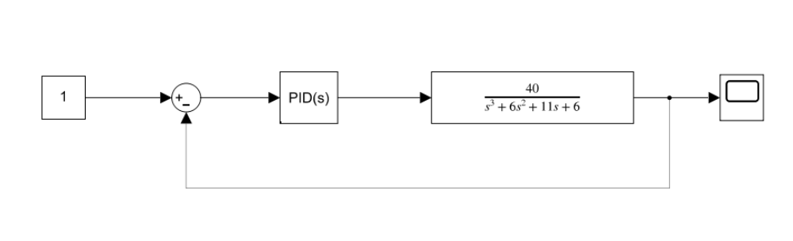
Graph :-
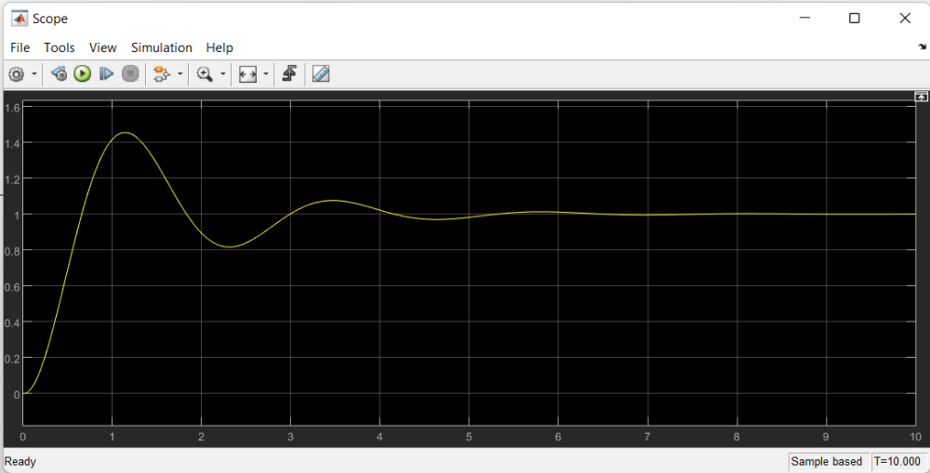
Results:

On performing the simulation and using Z-N tuning tables, we found the PID controller constants or parameters as:-
K_{P} = 0.9
K_{I} = 0.9569
K_{D} = 0.2116

Inference(s):
From the graph, it is clear that although the response curve has oscillatory response, the response curve has settling time of approx. 5 time units only and it is not showing any offset so, we can conclude that the PID controller is tuned perfectly.

Aim:- To study PID controller tuning using “Tyreus-Luyben” technique in Simulink.

Theory:-
The Tyreus-Luyben closed loop tuning method is used to obtain the controller constants(Kc, τI , τD in case of PID controller) in a system with feedback. This technique allows the tuning of processes that cannot run in an open loop environment. The main objective of this technique is to calculate the ultimate gain(Ku) and ultimate period(Pu) which is used to calculate the controller constants (tuning parameters).The numerical value of Kc which produces sustained oscillation with constant amplitude in case of proportional only control is called ultimate gain, Ku. The period of the corresponding sustained oscillation is called ultimate period, Pu. These two parameters Ku and Pu are used to calculate the tuning constants of the controller using T-N tuning table.
T-N settings are more conservative and it does not produce very oscillatory response or large overshoot which is possible in Z-N tuning method.

Tyreus-Luyben Tuning Table:-
 | K_{C} | τ_{l} | Τ_{D}
P | 0.5K_{u}
PI | K_{u}/3.2 | 2.2P_{u}
PID | K_{u}/2.2 | 2.2P_{u} | P_{u}/6.3

Transfer function used is given by:-

G(s) = $\frac{40}{\left(s+1\right)\left(s+2\right)(s+3)} = \frac{40}{s^{3}+6s^{2}+11s+6}$

Procedure:

Step1. Develop a SIMULINK block diagram.
Step2. Set the controller to a P-controller only.
Step3. Start to give values of K_{c} or K_{p} until the closed loop system exihibits sustained oscillation.
Step4. Note down the value of K_{p} at which sustained oscillation occurs. This value of K_{p} is the ultimate gain(K_{u}).
Step5. From the figure/graph, determine the ultimate period(P_{u}).
Step6. With the value of K_{u} and P_{u}, Calculate the tuning parameters of the PID controller using Tyreus-Luyben tuning table.
Step7. Introduce the PID parameters in the SIMULINK PID controller and perform a simulation to test the closed loop performance.
Observations:
On performing simulation in the SIMULINK, we get K_{u} = 1.5 and P_{u} = 1.881.

Table for PID Controller:-

Controller | K_{c} | τ_{l} | τ_{l}
PID | 0.6818 | 4.1382 | 0.2986

So,
K_{P} = 0.6818
K_{I} = 0.1648
K_{D} = 0.2036

Block diagram:-
Graph:-
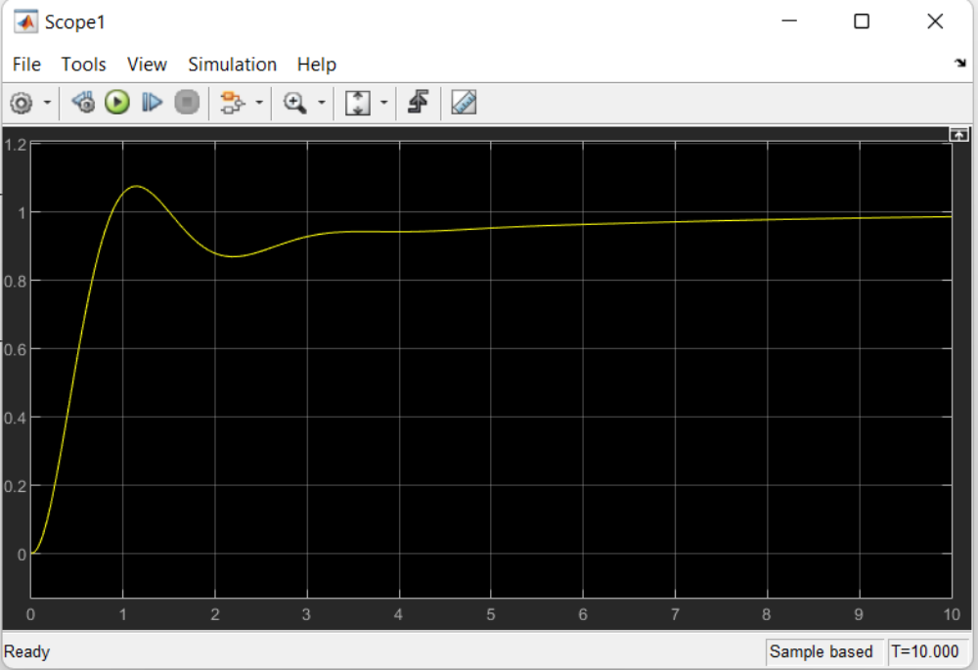

Results:

On performing the simulation and using T-L tuning tables, we found the PID controller constants or parameters as:-
K_{P} = 0.6818
K_{I} = 0.1648
K_{D} = 0.2036

Inference(s):
From the graph, it is clear that the response settling time is less than 10 time units and the overshoot is very less than that obtained in Z-N tuning method and TL method has also given less oscillatory response curve. So, we can conclude that the PID controller is tuned perfectly by TL method.

Aim:-To study the stability analysis using Root-Locus Diagram in MATLAB.

Theory:-
The feedback control system is stable if and only if all roots of the characteristic equation are negative or have negative real parts. Otherwise the system is unstable.
Characteristic equation of the closed loop system is:

1+G_{OL}=0
Where G_{OL} = G_{C}.G_{V}.G_{P}.G_{M}
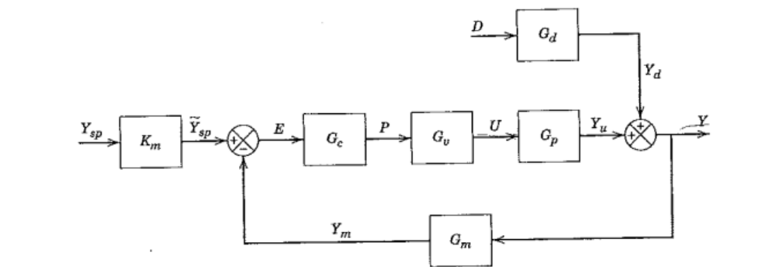

Standard block diagram of a feedback control system

A Root locus diagram provides a convenient display of how the roots of the characteristic equation change when a particular system parameter such as controller gain(Kc) changes.

Open loop transfer function used is:-

G_{OL}(s) = $\frac{4K_{C}}{\left(s+1\right)\left(s+2\right)(s+3)} = \frac{4K_{C}}{s^{3}+6s^{2}+11s+6}$

Procedure:-

1.Define the transfer function in MATLAB.
2.Use rlocus() function to plot the root locus diagram.

Observation:-
From root locus diagram, we can see that roots of the characteristic equation is -1,-2 and -3 when Kc=0.As Kc increases root at -3 decreases monotonically while other two roots converges and form a complex conjugate when Kc=0.1 .We also observed that for Kc>15,the complex roots cross the imaginary axis so they have positive real part and thus the closed loop system becomes unstable for Kc>15.

Graph:-
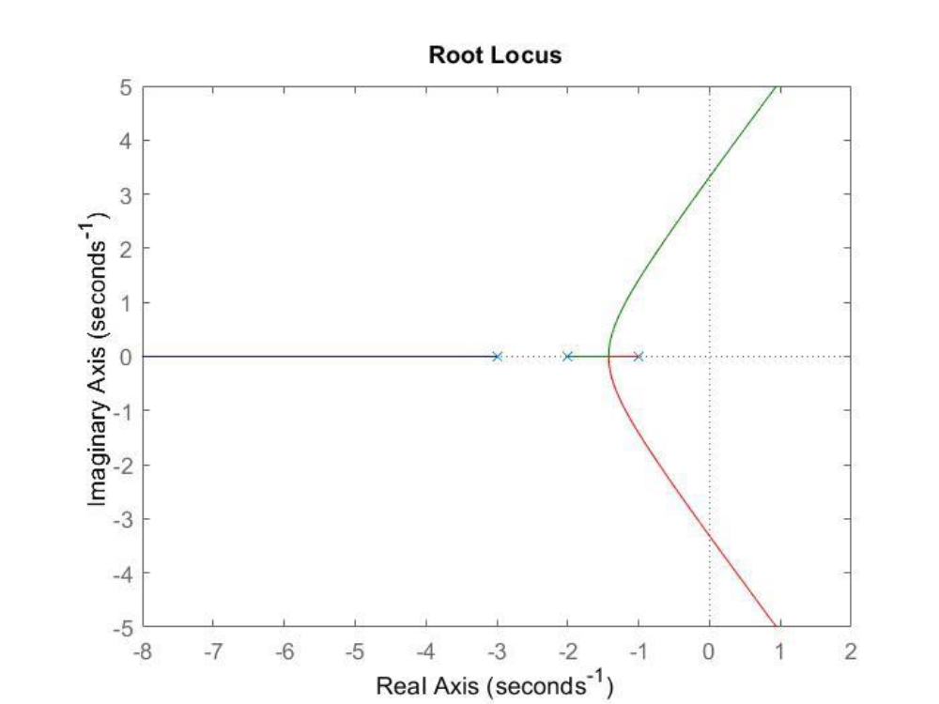

Result:-

From, root locus diagram, we have found that closed loop system is stable for Kc ϵ [0,15].

Inference:-
1.When Kc=0,the roots of the characteristic equation is -1,-2 and -3.
2.The process is stable for Kc ϵ [0,15].
3.When Kc=15,the process is critically stable with poles lying on imaginary axis.
4.As Kc becomes greater than 15,the system becomes unstable.
5.Thus we can conclude that system will be stable if the controller gain, Kc is less than 15.

